**FORM AND CONTROLLED ELEMENTS**

In React, controlled elements refer to form elements whose value is controlled by the state of a React component. This means that the value of the form element is stored in the component's state, and any changes to the value are handled by React through state updates.

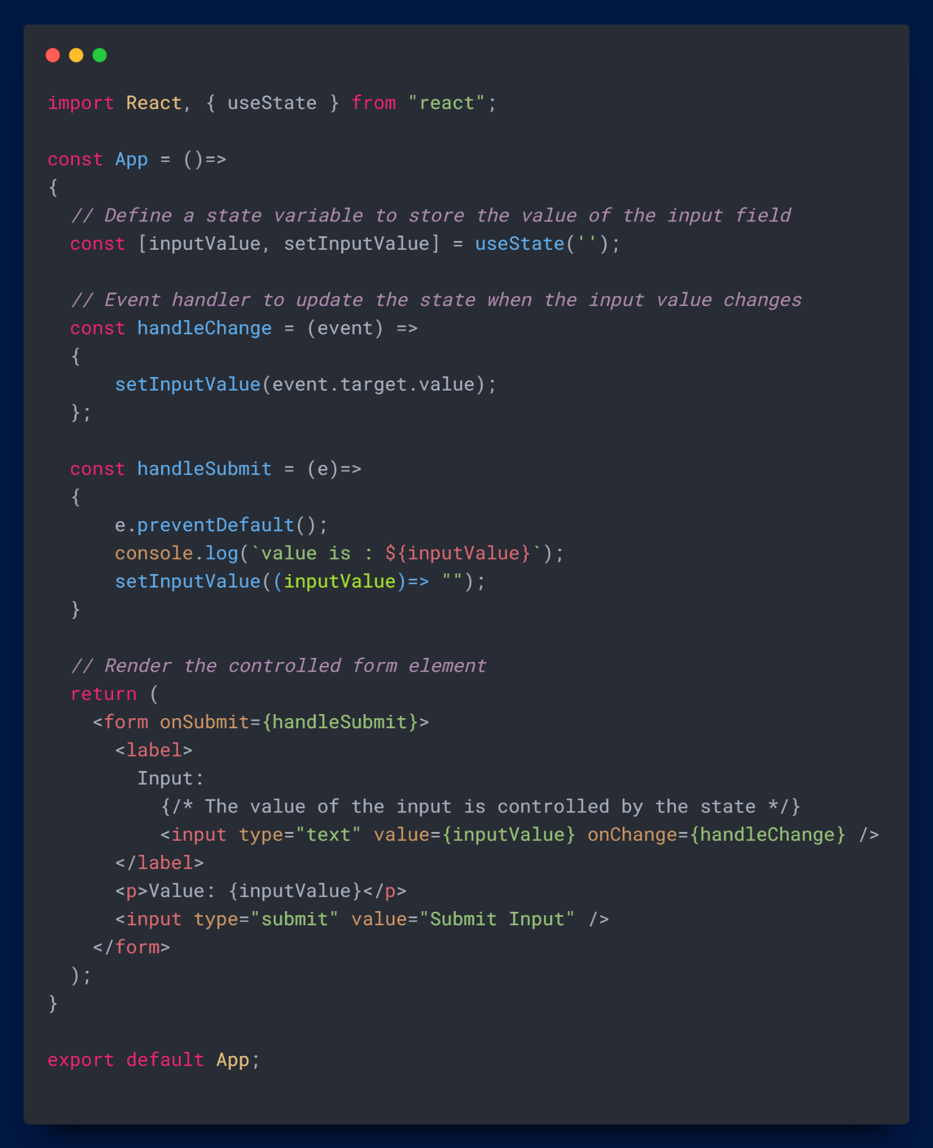

**Do you find it helpful?**

**Let me know down in the comments**



[](https://www.linkedin.com/in/anubhav-gupta-b68946132/)

**Click To Follow For More On LinkedIN**